

Module Project Report for
CS6461 – Computer Vision Systems

Student Name : <First Name followed by Last Name in bold black>
Student ID : <Full UL Student ID in bold black>

Revision Timestamp: 02/11/2025 20:06:18

The table of contents can be automatically refreshed to reflect the contents of the document, so you do not need to touch it manually. Ensure this is updated before submitting by right-clicking on each of the table of contents and table of figures and selecting Update Field -> Update entire table. Do not provide manual edits for automatically generated text.
Replace or delete all red directive text as appropriate.
Note that the text below contains helpful links to explanatory videos.
If you have MS Word, do not generate any of the automatically generated text, such as the table of contents, the details of the references.
Contents
Introduction 2
First Task (appropriately renamed) 2
Second Task (appropriately renamed) 3
Third Task (appropriately renamed) 3
Conclusion 3
References 4

Figure 1: Architecture used to create AI/ML ecosystem for Model X 3

Introduction
The heading format for “Introduction” in MS Word is Heading 1. Describe here the required task(s). Make sure that the paragraphs below have naming conventions that reflect this. Do not assume that the reader has read the assignment.

First Task (appropriately renamed)
The selection below contains an example figure.
Below is an example captioned diagram, made using Reference-> Insert Caption (see video guide)
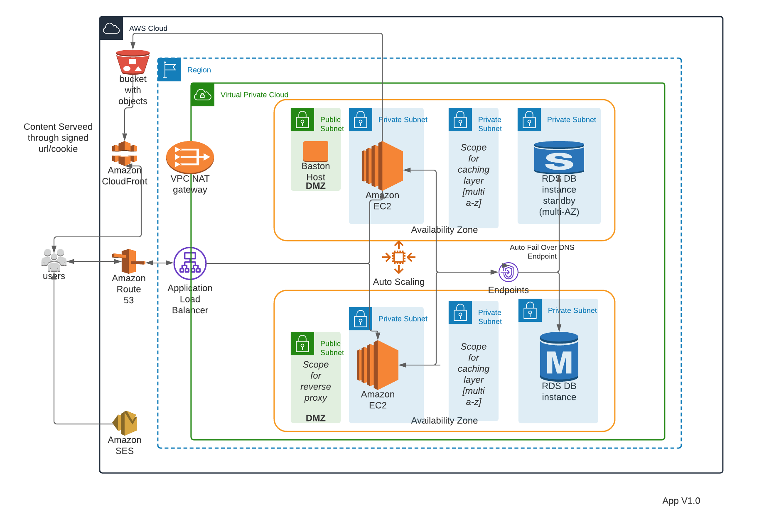
Figure 1: Architecture used to create AI/ML ecosystem for Model X
All figures used should be cited in the text. A figure should be referred to in the text of the document using References->Cross-reference (see video guide) in the Word toolbar, using only label and number e.g., Figure 1. All such cross-references should be generated automatically in this way.

Second Task (appropriately renamed)
Elaborate on second task here.

Third Task (appropriately renamed)
If you use external references, you must explicitly reference in a form such as (Patrick Denny, 2024) . Use Citations and References (explained in this video tutorial) to do this and insert the References at the end as indicated in the video. These will all then show up automatically in the references section, where it will be possible for a person to check the references. Each reference in the reference section must be different (this will happen automatically if automatically generated). Attribution must be given to all unoriginal content used by the author.

Conclusion
If a conclusion is needed, provide it here. The report shall be submitted as a PDF.

References
Patrick Denny. (2024, February 26). AWS Cloud Security - Tuesday Week 4 Material. Retrieved from CS5024 - Theory and Practice of Advanced AI Ecosystems: https://learn.ul.ie/d2l/le/lessons/17937/topics/634587

